CS3050 Homework #5 by Colin Fuemmeler cjffqw

1. a) A B C D E F G H

A 0 1 0 1 0 0 0 0

B 0 0 1 0 1 0 1 0

C 1 0 0 0 0 0 0 0

D 0 0 1 0 0 0 0 0

E 0 0 0 0 0 0 0 1

F 0 0 0 0 0 0 0 0

G 0 0 0 0 0 1 0 0

H 0 0 0 0 0 1 1 0

b) A { B, D } E { H }

B { C,E,G } F { }

C { A } G { F }

D { C } H { G,F }

c) 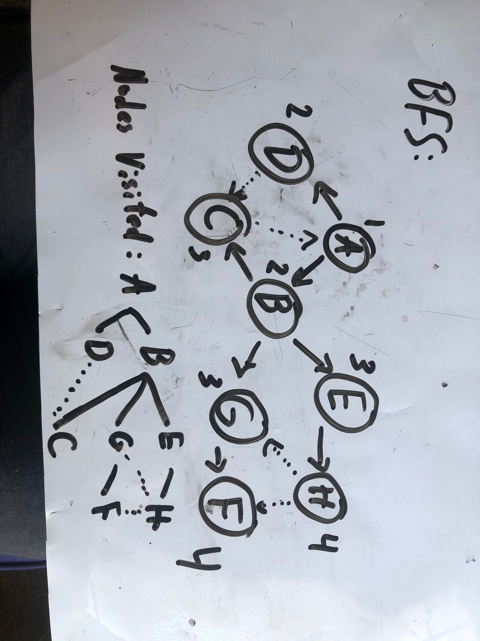

d) 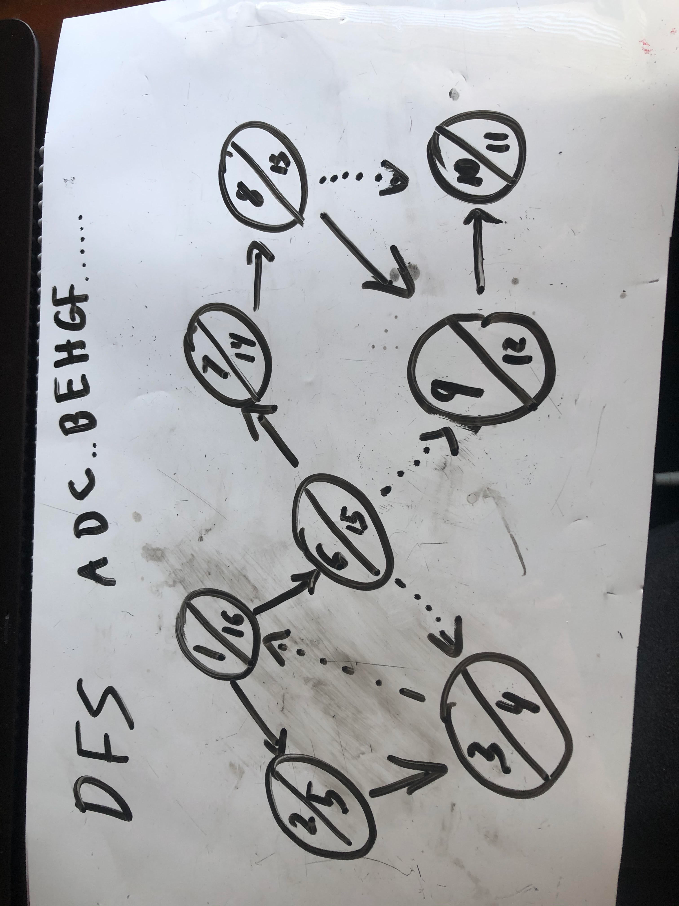

Problem #2

In order to find islands within a Boolean 2D matrix I would iterate one value at a time through the array. I would also make a list that stores coordinate values. Whenever the program lands on a 1, it will “scan” the surrounding array slots up to 1 index forward or back, as well as up and down. If none of the 1s in the group found have their coordinates stored in the list, then it will store the index of the first ‘1’ it landed on and add one to the island count. If one of the 1s in the group DO have their coordinates stored, then the group of 1s are already part of an island, and the program should skip to the next iteration.

Problem #3

Directed Graph:

White Gray Black

White none none none

Gray tree back cross,

forward

Black none none none

Undirected Graph:

White Gray Black

White none none none

Gray tree back back

forward cross

forward

Black none none none

Problem #4

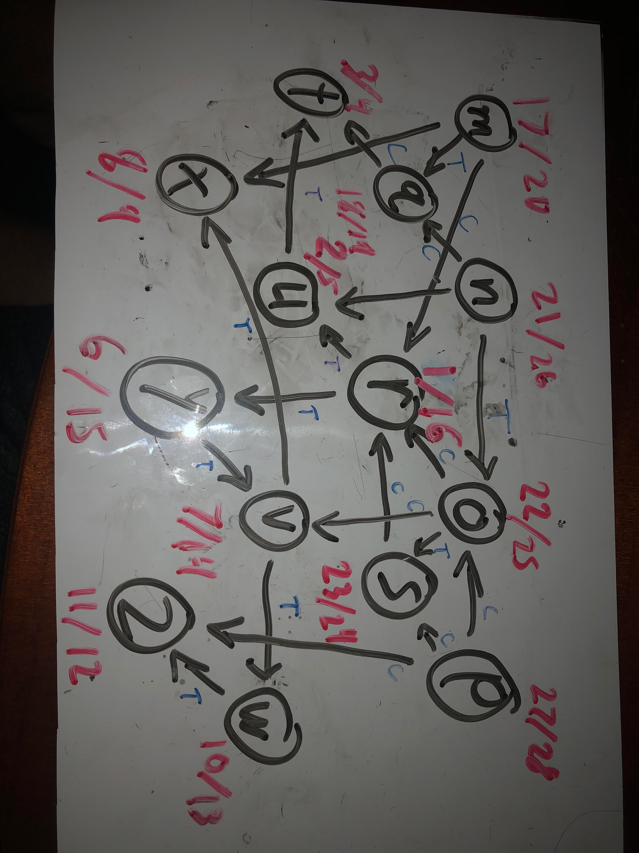

Topological Order: p, n, o, s, m, q, r, y, v, w, z, x, u, t

Problem #5

|| r || u || q. t. y || x, z || s, v, w

